**Project Requirement**

**Framework  
fornt-end : visual studio (mvc dot net) entity framework  
database: microsoft sqlserver  
Project dead line : 1 7 june 2023**

**Business Partner**

1. **Vendor/Supplier**  
   -- CRUD **( company and contact person)**

--- Inactive option

--- Report

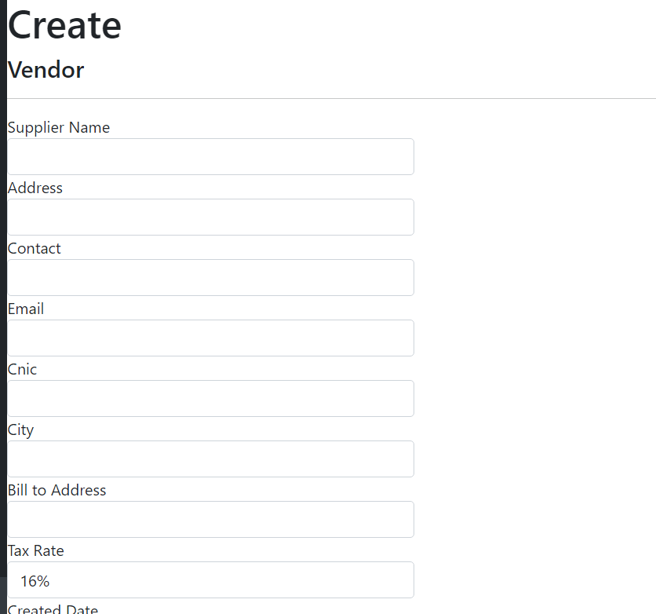

1. **Customer**

-- CRUD

--- Inactive option

--- Report

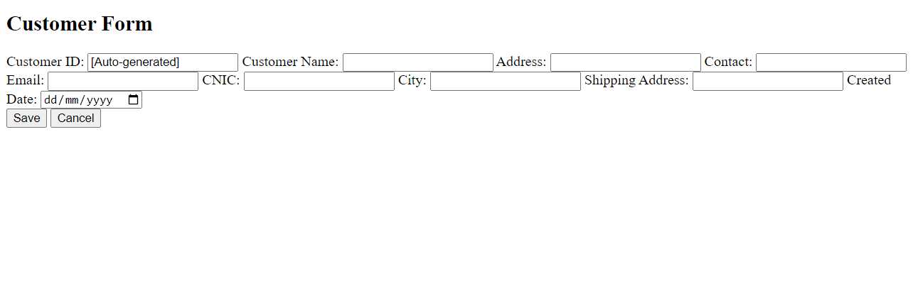

**Product**  
--CRUD **( company and contact person)**

--Inactive option

--Report

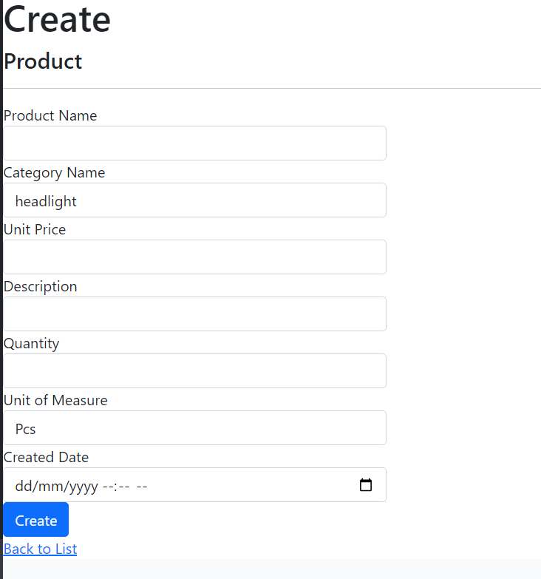

**Category**

--CRUD

--Inactive option

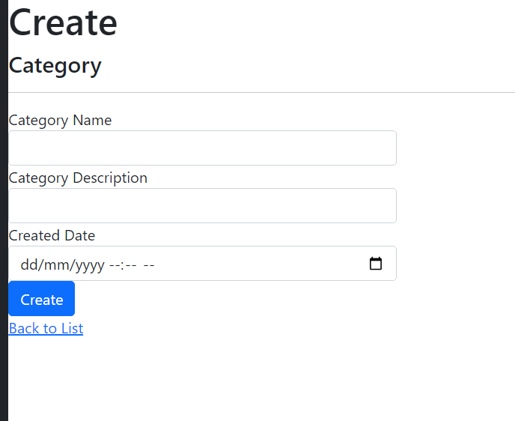

**Inventory**

--CRUD

--Inactive option

**Tax**  
 --CRUD

--Inactive option

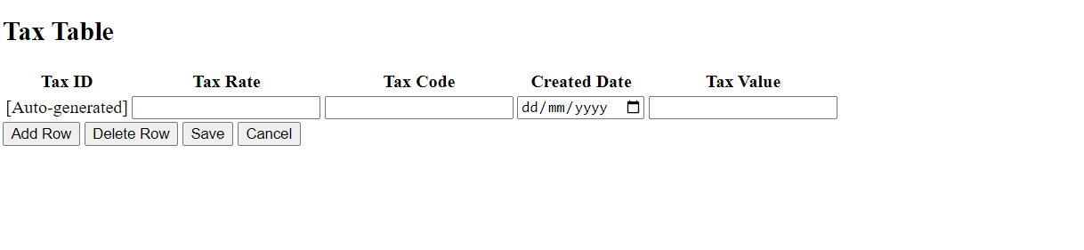

**Role   
--** Crud

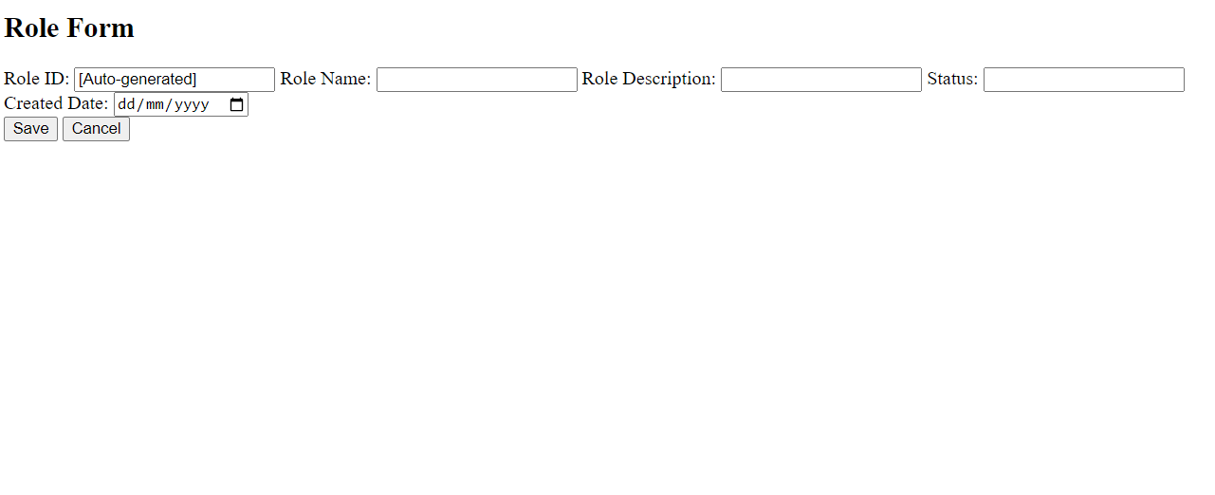

**Unit of measure**

--CRUD

--Inactive option

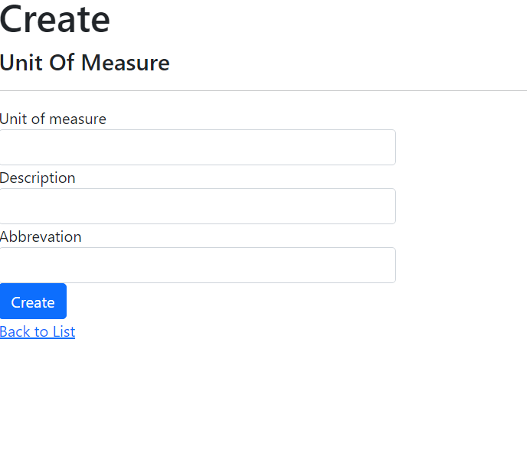

* **Purchase Cycle**  
    
  **Request for Quotation (RFQ)**  
  --- CRUD

---- Line item option ( multiple product can be added in one RFQ

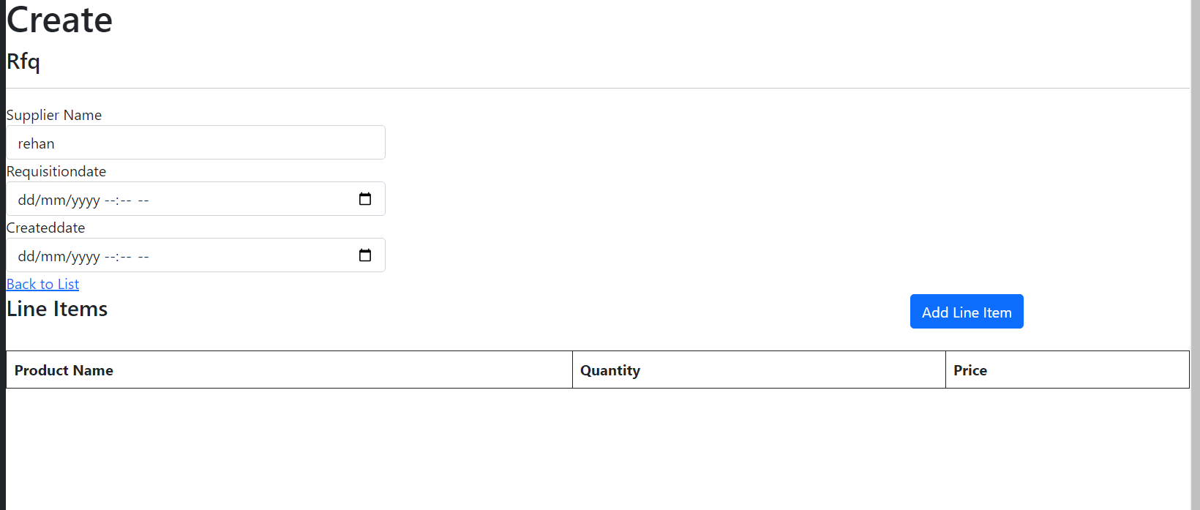

**Purchase Quotation**

--- CRUD

---- Line item option ( multiple product can be added in one RFQ

--- Approval, when quotation status is approved then purchase order should automatically generated .

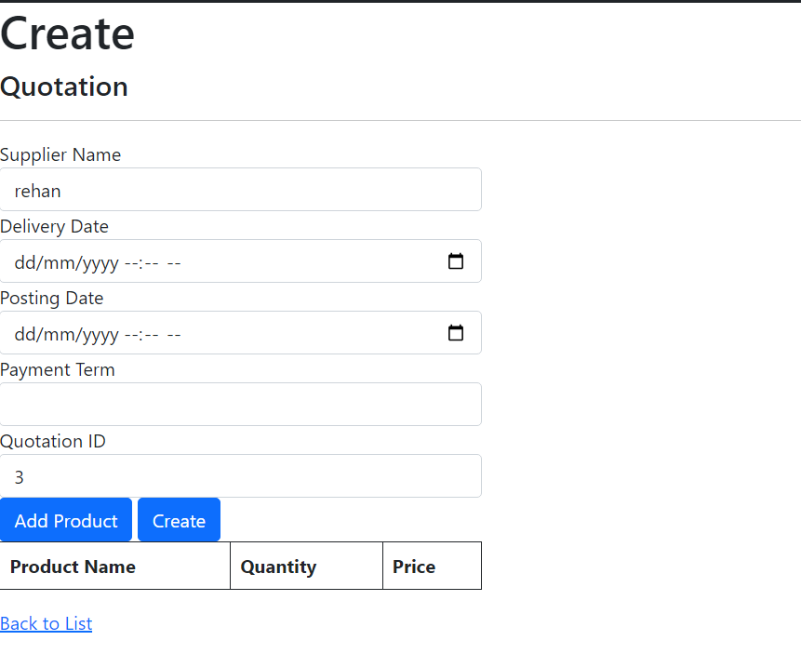

**Purchase Order**

--- CRUD

---- Line item option ( multiple product can be added in one RFQ

--- Approval, when Purchae order status is approved then Goods Receipt Note should automatically generated .

--- pruchase Order Report in PDF form

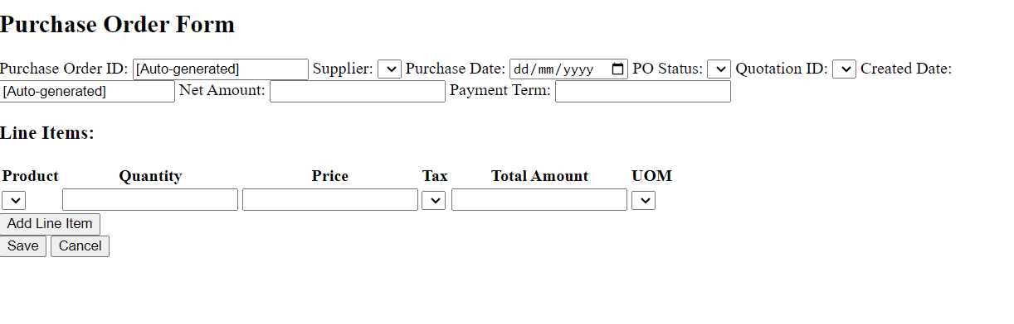

**Goods Receipt Note**

--- CRUD

--- Report

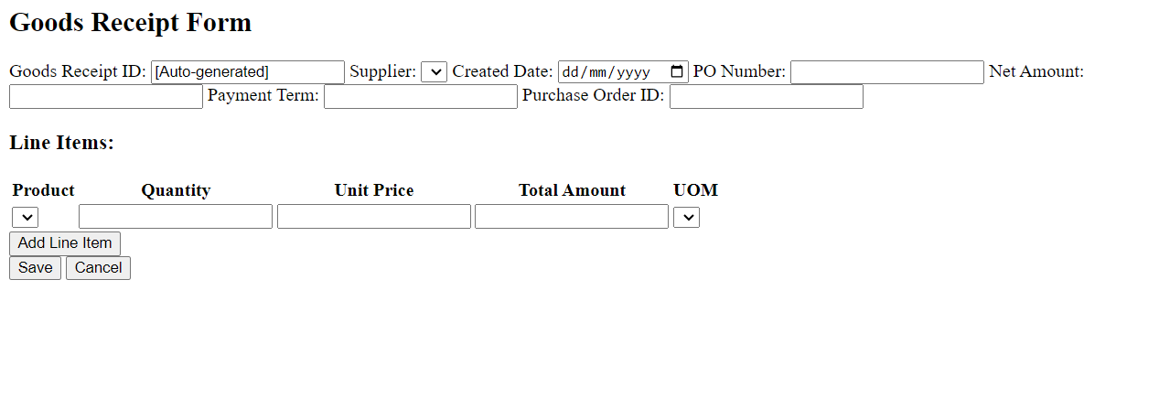

**Purchase Invoice**

-- CRUD

-- Report

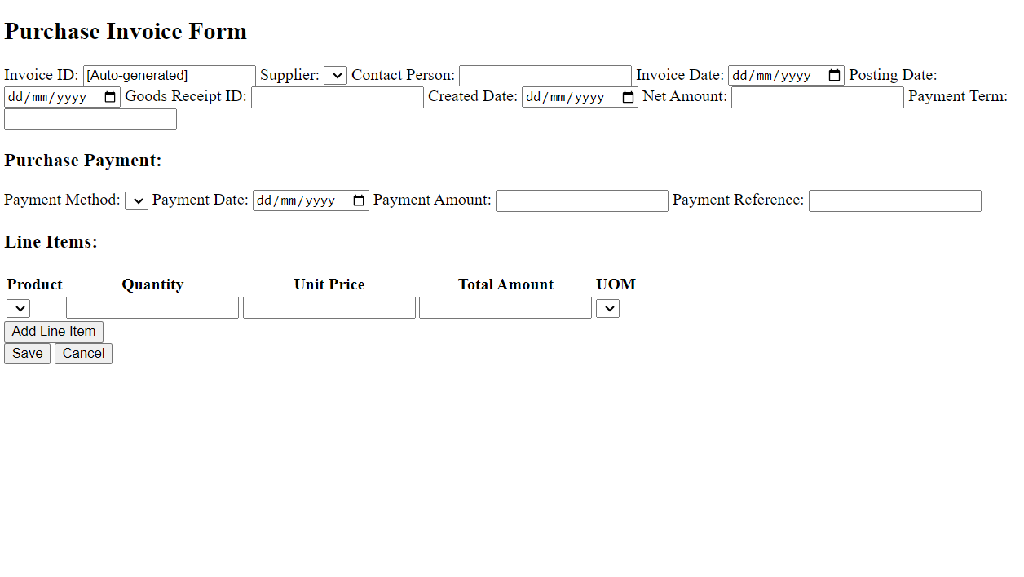

**Payment**

-- crud

-- payment

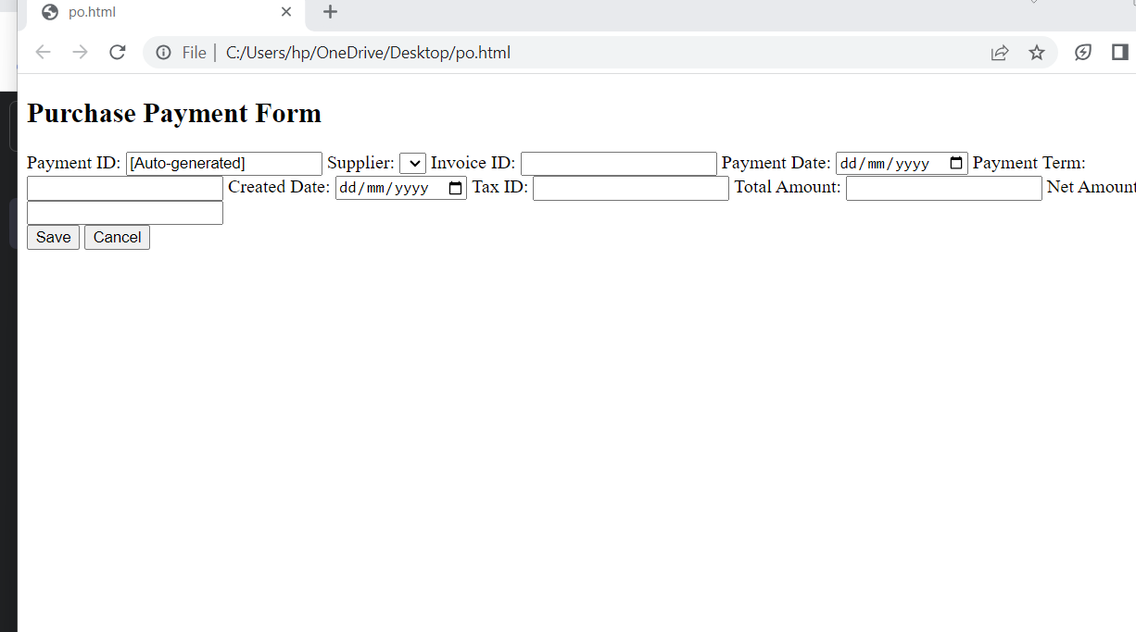

**Supplier credit note**

Crud

Report

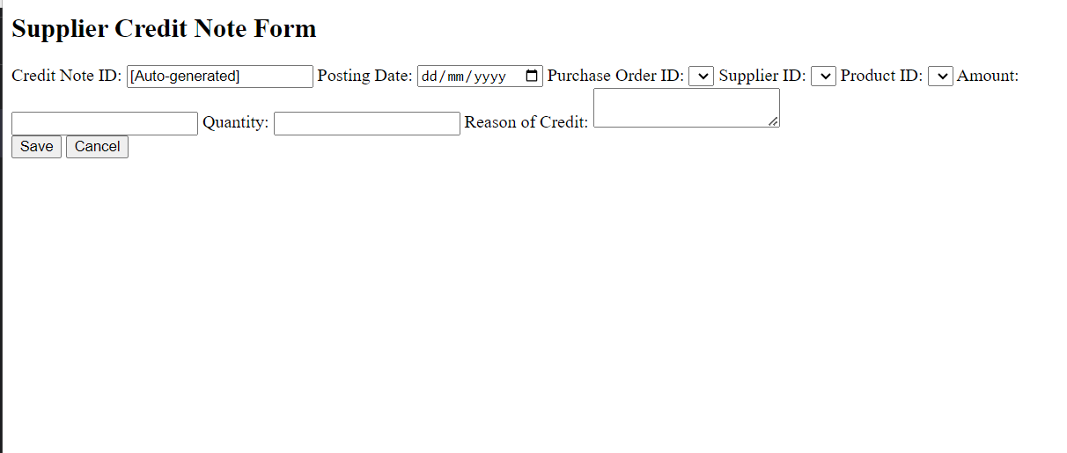

**Sale Cycle**

**Sale Quotation**

--- CRUD

---- Line item option ( multiple product can be added in one Sale quotation

--- Approval, when Sale Quotation status is approved then sale order should automatically generated .

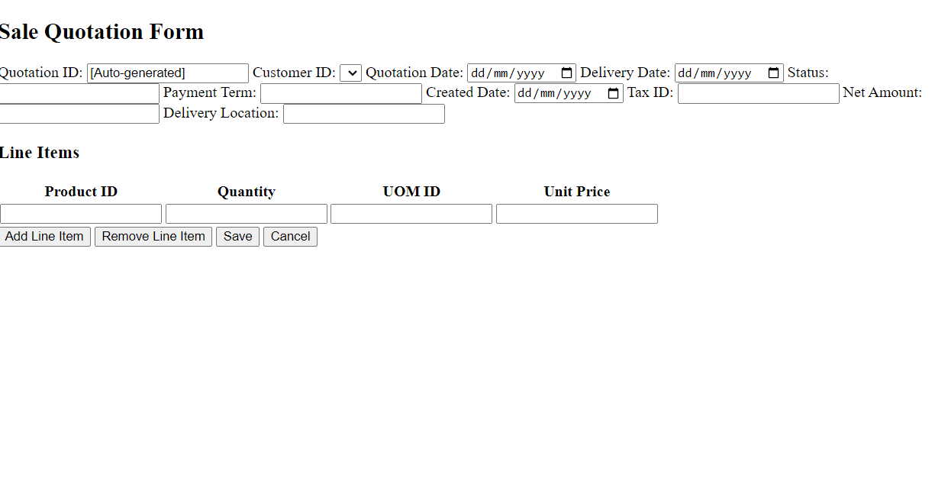

**Sale order**

--- CRUD

---- Line item option ( multiple product can be added in one sale order

--- Approval, when Sale Order status is approved then sale Delivery Note automatically generated .

--- Report

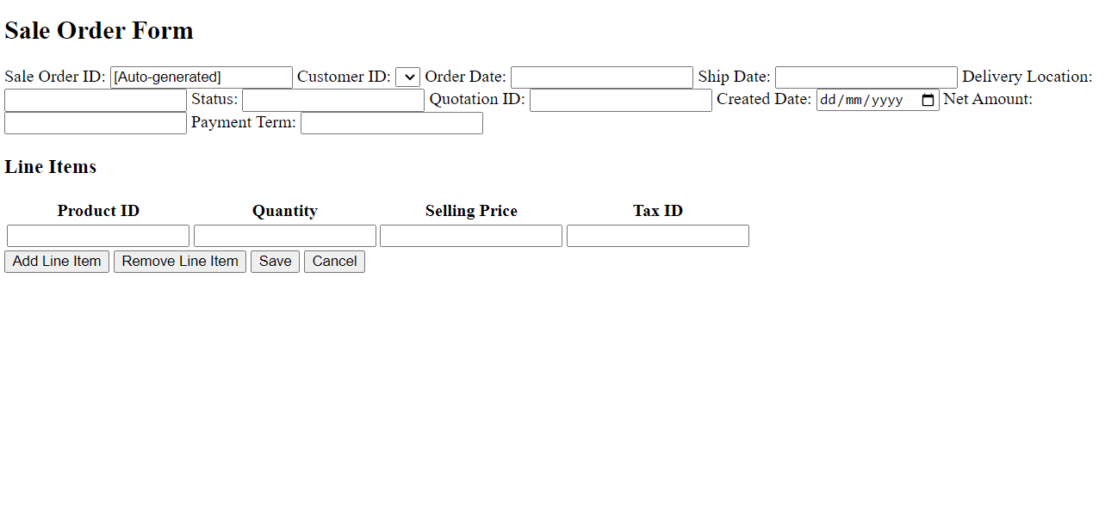

**Delivery Note**

--- CRUD

--- Report

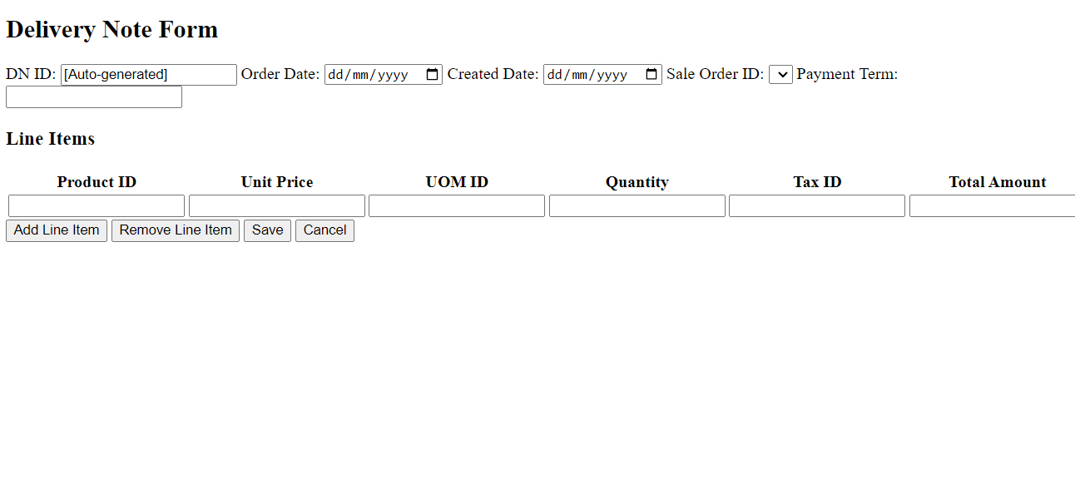

**Sale Invoice**

--- CRUD

--- Report

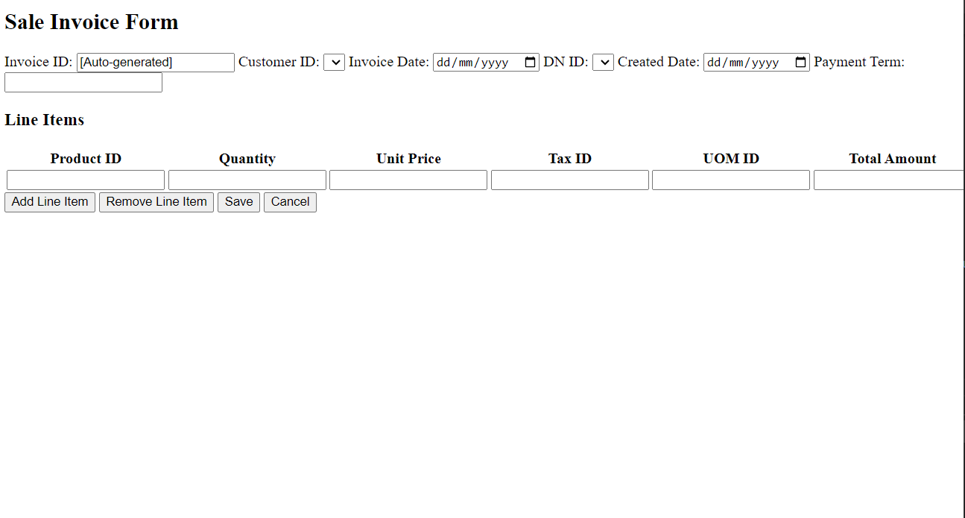

**Payment**

--- CRUD

--- Report

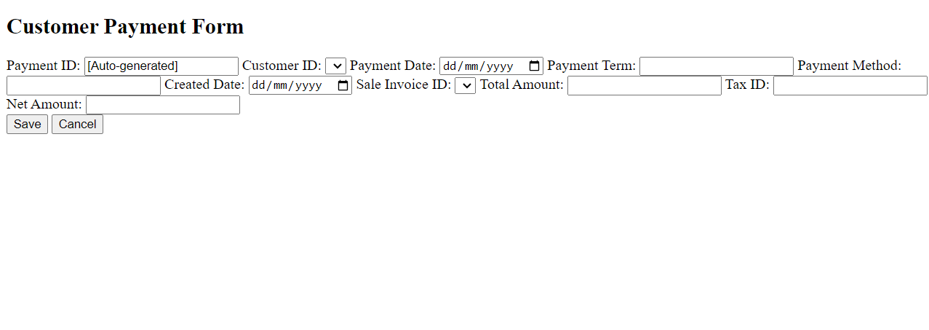

**Customer return**--- crud

---report

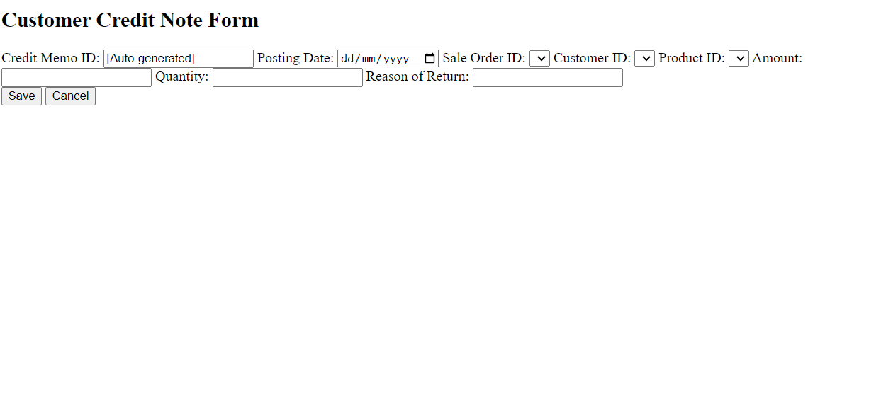

**Graph representation of sale, purchase and Inventory.**